26th Annual Rural Health Educational Summit
March 30-31, 2020
Hilton University of Florida Conference Center
1714 SW 34th Street Gainesville, FL 32607

Exhibitor Invitation

O
n behalf of the Florida Rural Health Association (FRHA) Board of Directors and members, we cordially invite you to join FRHA at our 26th Annual Summit on March 30-31, 2020 at the Hilton University of Florida Conference Center.
Formed in 1992, FRHA was created to provide a mechanism through which interested individuals and organizations in Florida unite in advocacy and ensure that all residents of rural Florida have access to a continuum of affordable healthcare. It is this common interest that binds the FRHA membership and has allowed the development of a common voice for rural health.
Who attends the annual FRHA Summit?
The Summit reaches a diverse audience including: rural hospital administrators and staff, rural health network directors, rural governments, county health departments, public health workers, legislators, nonprofits, medical students, educational institutes and individuals interested in the health and well-being of rural Floridians.
Reasons to exhibit at the FRHA Summit:
- Exhibit space provides face-to-face access to rural health professionals and administrators working in hospitals, clinics, nonprofits, and government across Florida.

- Full access to top-notch Summit topics and speakers. Please visit www.floridaruralhealth.org for session descriptions and a full agenda in the coming months.

- Exhibitor recognition in the Summit program, FRHA newsletter, FRHA website.

- Exhibiting companies will be provided with a list of attendees’ contact information post meeting.

- Recognition as an exhibitor of an organizations committed to improving the health of rural Florida.

Exhibitor space is limited, so reserve your booth today!

EXHIBITOR LEVELS: 2020 FRHA SUMMIT
PLATINUM EXHIBITORS -$1,850 (limit 4)
This level of sponsorship includes:
- Two Registration Badges, including meals
- Two FRHA Organizational Memberships
- Introductory email blast
- Full Page Advertisement in Summit Program
- Prime Exhibit Location
- One skirted, 6-foot table in the Pre-function Area

GOLD EXHIBITORS - $1,600 (limit 5)
This level of sponsorship includes:
- Two Registration Badges, including meals
- Two FRHA Organizational Memberships
- Half-page ( ½ ) advertisement in Summit Program
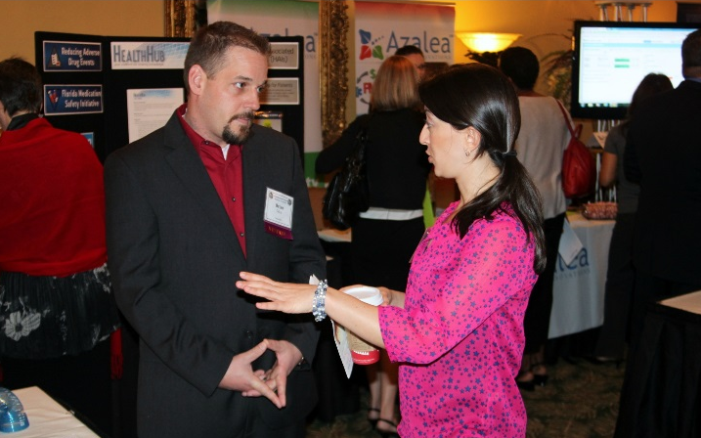
- One skirted, 6-foot table in the Pre-function Area

SILVER EXHIBITORS - $1,050 (limit 3)
This level of sponsorship includes:
- One Registration Badge, including meals
- One FRHA Organizational Membership
- Fourth ( ¼ ) page advertisement in Conference Program
- One skirted, 6-foot table in the Pre-function Area

BRONZE EXHIBITORS - $800 (limit 6)
This level of sponsorship includes:
- One Registration Badge, including meals
- One FRHA Organizational Membership
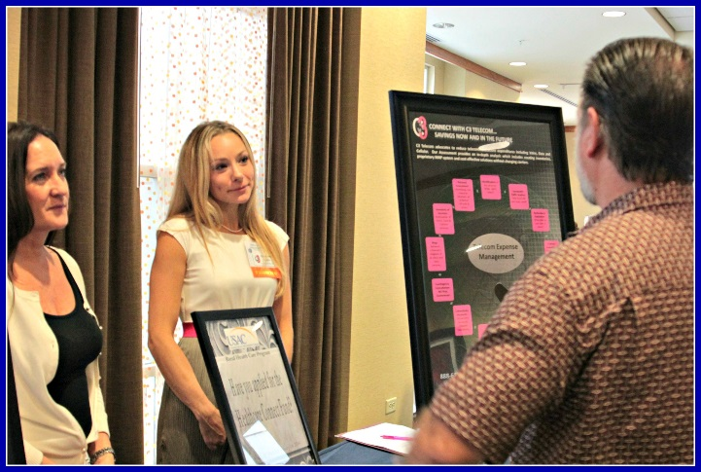
- Eighth (1/8) page advertisement in Conference Program
- One skirted 6-foot table in the Pre-function Area
NONPROFIT EXHIBITORS - $250 (limit 4)
This level of sponsorship includes:
- Bronze exhibitor benefits at a reduced price

PROGRAM ADVERTISER ONLY
- Full page- $500
- Half page- $300
- Quarter page- $175
- Eighth page- $100

SPONSORSHIPS/EDUCATIONAL GRANTS
For customized sponsorship packages or other funding opportunities, please contact Laura Moore at lmoore@srahec.org or 386-462-1551 ext 115.

TERMS OF EXHIBIT
TERMS OF PAYMENT: Each exhibit space application/contract submitted must be accompanied by ½ of the Sponsorship amount. If payment does not accompany application the booth space will not be held. The full payment is due on or before March 1, 2020.
BOOTH SPACE CANCELLATION TERMS: It is agreed that (a) if a company cancels its space between prior to February 1, 2020, the company will be receive a full refund (b) if cancellation occurs after February 2, 2020, FRHA will refund all but $500. In the event of booth space cancellation, the Exhibitor must notify FRHA in writing or refunds will not be considered. FRHA reserves the right to cancel this contract in any event, on written notice to applicant, if the organization considers it inadvisable to hold the Exhibition.
GENERAL CONDUCT OF EXHIBITS: The following practices are prohibited by the FRHA: (1) noisy electrical or mechanical apparatus interfering with other exhibitors; (2) canvassing or distribution any material outside the Exhibitor’s own space without FRHA approval; (3) subleasing of exhibit space (one company name per booth); (4) soliciting participation in surveys or otherwise harassing registrants; (5) publicizing and/or maintaining any extracurricular activities, inducements, demonstrations, or displays away from the exhibit area during the meeting and exhibit hours; (6) contests or games of chance conducted on-site that violate local gambling laws; (7) the use of any tobacco product. The use of open audio systems is discouraged. Requests to use an open audio system must be approved by the FRHA, and the Exhibitor must agree to discontinue its use if the sound level is deemed to be objectionable to the registrants or adjacent Exhibitor’s. Exhibitors are requested to staff their exhibits during show hours with personnel attired in a manner consistent with the decorum and the meeting, as well as knowledgeable in the products and policies of the company.
INSURANCE: All Exhibitors, their contractors and suppliers working in the exhibit hall are required to carry liability insurance. Exhibitors must operate and maintain their exhibit so that no injury will result to any person or property. Every reasonable precaution is taken by the exhibition location and the FRHA to safeguard and protect the Exhibitors’ property while at the exhibition. All Exhibitors are strongly urged to obtain full-coverage temporary insurance for their merchandise and displays while in transit and while at the exhibition.
INSTALLATION OF EXHIBITS: Exhibits must be set by 8 a.m. on March 30, 2020. Labor is not available for setup or dismantling. Exhibitors are responsible for delivery and return arrangements of their booth.
EXHIBIT HOURS: Exhibits must be staffed and remain intact throughout the show hours.
DISMANTLING OF EXHIBITS: Exhibitors are responsible for delivery and return arrangements of their booth.
FLAMMABLE MATERIAL: No volatile or flammable fluids, substances, or materials of any nature prohibited by local ordinances, the Fire Prevention Bureau, or insurance carriers may be used in any booth.

2020 FRHA SUMMIT EXHIBITOR APPLICATION
Please complete and return to reserve your space
Name of company as it should be listed: | ______
Name and title of person in booth: | ______
Email address of person in booth: | ______
Name of second person in booth:  (Platinum and Gold sponsors only) | ______
Names of additional people in booth at the same time: ($200 each) | ______
Exhibitor level: | ______
Amount enclosed: | ______
Electricity needed? ☐Yes ☐ No
Logo/graphic for program included? ☐Yes ☐ No
Please send a color, high resolution (220 ppi; PNG, JPEG and PDF files) logo/advertisement to lhampson@srahec.org.
Ad specs: Full page-7.5” x 10”; Half page- 7.5” x 5” or 3.75” x 10”; Quarter page- 3.75” x 5”; Eighth page- 3.5” x 2.5”
Please check the box(es) that best describe your organization:
☐Healthcare Agency ☐Association/Society ☐Information
☐Workforce Development ☐Government Agency ☐Provider
☐Non-Profit Agency ☐Telemedicine ☐Electronic Health Records
☐Education/Training ☐Other: ______
FRHA accepts the following forms of payment:
☐Check ☐ Mastercard ☐ Visa ☐Invoicing
Name and email address of payment contact:  (If different than booth representative) | ______
Credit Card Payment:
Credit Card Number: ______
Exp. Date: ____/____
Security Code: ______ (three digit number on back of card)
Signature: ____________________________________________________
Name on Card: ______
Billing Address: ______

*Please call 386-462-1551 to process a credit card over the phone*
Please return this completed form with payment to:

Mail: Florida Rural Health Association
Attn: Laura Moore
14646 NW 151st Blvd
Alachua, FL 32615

Email: lmoore@srahec.org
Phone: 386-462-1551 x115

